

Reduced Rates!!

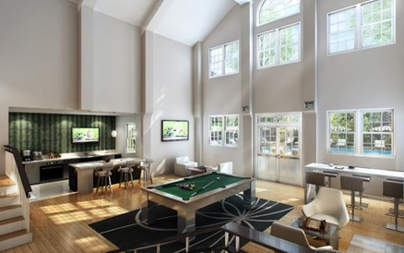

**Community Amenities**

•Newly Redesigned Clubhouse - NOW OPEN!

•Newly Renovated 24-Hour, Fully-Equipped Fitness Center

•Theatre-Style Media Center

•Complimentary Coffee Bar

•WiFi Throughout Common Areas

•Agility Course in on site Bark Park

•Heated Swimming Pool

•NEW State-of-the-Art Package Concierge Program

•Recycling Program Onsite

•Monthly Social Activities Programming

•We Love Pets!*

•Covered Parking Available

•Minutes to I-495/290/90

•24-Hour Emergency Maintenance

•On-Site Professional Management

•Flexible Lease Terms Available

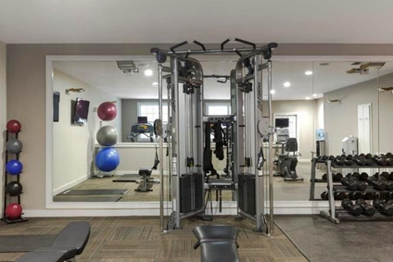

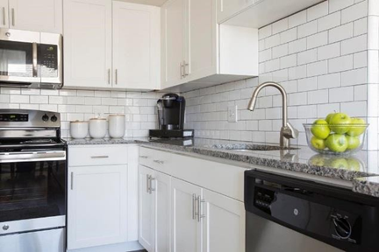

**Newly renovated homes available**

1 Bedrooms starting at $1547

2 Bedroom homes starting at $1815

*Prices and availability change daily*

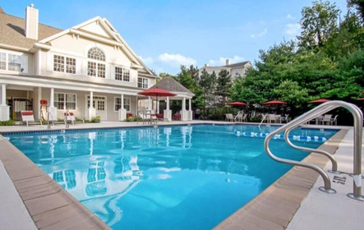

**Apartment Amenities**

•Granite Countertops in Kitchens & Baths*

•Ample Counter Space

•Hardwood-Style Flooring

•Stainless Steel Energy Efficient Lighting

•Individual Climate Control for Year-Round

•Full-Sized Washer & Dryer

•Scenic Views*

•Extra Storage Available

•Large Closets Offer Abundant Storage

**Affordable Apartment Homes Available with rents starting at:**

$1,185/month for 1 Bedroom

$1,394/month for 2 bedrooms

*Income restrictions apply*